**The Report for The Course Exercise of Data Structures**

Topic: Student Management System

Group: ADT

Members:1911521109,1911521111,1911521112.1911562107

Data: User’s Manual

**School of Computer science**

Contents

TABLE OF FIGURES 1

Work Cycle 2

Features 3

Feature Details 4

Example 5

Step 1: 5

Step 2: 6

Step: 3 7

Step 4: 7

Conclusion 8

# TABLE OF FIGURES

Figure 1: Main Menu at int main of main.cpp 5

Figure 2: Choose where you want to perform the operation 6

Figure 3: Inserting A New Student’s Record in the System 7

# Work Cycle

This Student Management System Works on a four step cycle.

* **Choose Function e.g. Insert, Remove, Update..**
* **Choose Where (Linked List) you want to perform the action**
* **Insert Required Values to perform the operation**
* **Return to the main Menu.**

# Features

The function featured in this system are

* Insert
* Remove
* Update
* Inquire
* Sort
* Count ( Appears in Inquire )

All based On Linked List.

# Feature Details

The Software can do:

* Insert Student
* Insert Course
* Insert Marks
* Delete Student by Student Name
* Delete Course By Course ID
* Delete Marks By Student name + Course ID
* Update Student by name
* Update Course By Course ID
* Update Marks by Student name + Course ID
* View List of All Student
* View List of All Course
* View List of All Marks of All Students By Course
* Sort Students by Student Name
* Sort Course by Course ID
* Sort Marks by Marks Per Course

# Example

## Step 1:

Let’s say we want to insert a student in the system.

Upon entering the system will look like this –

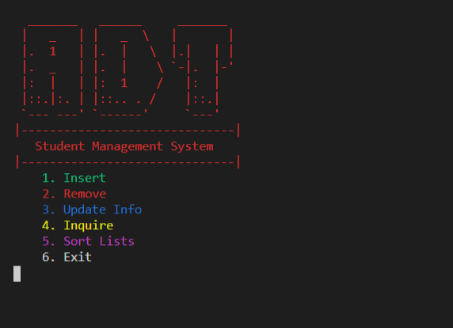

Figure 1: Main Menu at int main of main.cpp

## Step 2:

So now we choose “insert Option from the menu

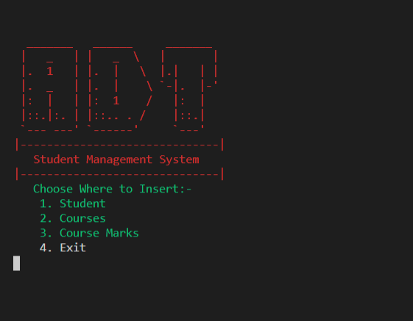

Figure 2: Choose where you want to perform the operation

## Step: 3

Now enter the information the system askes.

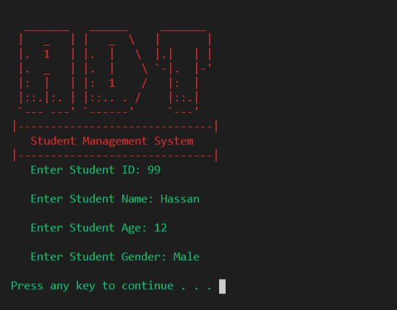

Figure 3: Inserting A New Student’s Record in the System

## Step 4:

When Step 2 is completed, it will ask to press any key to return to main menu. Starting the Cycle all over again.

Retaining all the information in prime memory in a linked list.

# Conclusion

The Purpose of this software is to demonstrate the implementation of linked list or any data structure and algorithm. This software stores all data in prime memory and will be lost once it is closed.